PERKINELMER

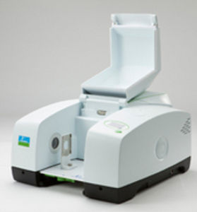

APPLICATION:

* Characterization of textile fibre.
* Detection of total petroleum hydrogen in soil.
* Determination of oil and greese in water with mid-nir
* Fatty acid methyl easter analyser

AMETEK

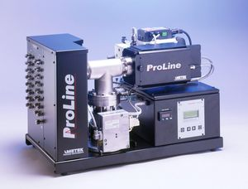

APPLICATION:

* Biomass studies
* Pharmasueticals

NDC

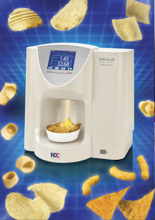

Application:

* Food industry
* Pharmaceutical industry.



Ocean optics

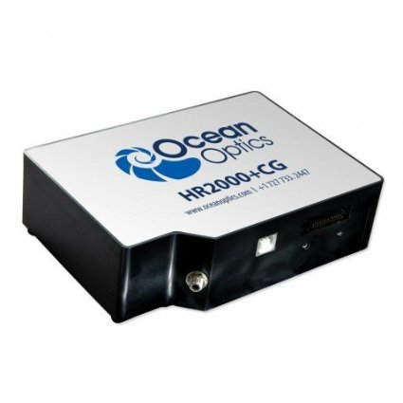

Price- $5437+ shipping